**Intergenerational Income Advancement and its Relation to Inequality**

Kincaid Youman

**Executive Summary**

Previous work has found a negative correlation between intergenerational mobility and income inequality, measured by the Gini coefficient, in the US and across countries (Corak 2013, Chetty et al. 2014a). In this paper, I analyze the relationship between intergenerational mobility and inequality in the United States using a measure alternative to those used by Corak (2013) and Chetty et al. (2014a). I measure mobility by the probability of a child advancing to a higher income quintile than that of his or her parents, conditional on him or her being born with parents in one of the lowest four quintiles. I abbreviate this measure P(B). I investigate the relationship between P(B) and inequality, where inequality is measured by the Gini coefficient. Both of these measures are applied at the level of the Commuting Zone (CZ).

Most data in this paper are taken from Chetty et al. (2014a). P(B) is calculated using quintile transition matrices reported by Chetty et al. (2014a), who calculated the probabilities using anonymous federal income tax records. After calculating P(B), I regress it on the Gini coefficient across CZs, estimating linear, quadratic, and cubic models. I find that, excluding two outliers, P(B) is best described by a quadratic equation in the Gini coefficient which slopes downwards for about 90% of the data. In a basic linear model, P(B) has a small, negative correlation with the Gini coefficient across CZs. I then estimate this relationship in different geographic divisions. I propose that the urban and nonurban breakdown of the relationship offers some explanation as to why the relationship for the whole US is quadratic. The Midwest has the strongest negative relationship between P(B) and the Gini coefficient, while urban areas have a small to nonexistent relationship between the two variables.

**Introduction**

Economists have found a negative correlation between intergenerational mobility and income inequality both across countries and US commuting zones (CZs) (Corak 2013, Chetty et al. 2014a). Corak (2013) and Chetty et al. (2014a) measure mobility by the intergenerational elasticity of income (IGE) and absolute upward mobility, respectively. A regression of log child income on log parent income yields IGE as the coefficient on log parent income, and absolute upward mobility measures the mean income rank of a child with parents in the 25th percentile. In this paper I use an alternate measure of mobility which emphasizes the upwards mobility of the poor and describes one aspect of the American Dream.

To measure mobility, I find the probability that a child’s family income as an adult is in a strictly higher quintile than their parent’s family income, conditional on their parent being in one of the lowest four quintiles. I find that this measure has a convex quadratic relationship with the Gini coefficient across CZs, with about 90% of the data laying on the decreasing portion of the curve. This relationship may be quadratic due to differences in the urban and nonurban labor markets. Nonurban CZs appear to be a primary factor in contributing to the downward sloping portion of the curve compared to urban CZs which disproportionately lay on the shallow portion. A similar pattern exists between the Midwest and the rest of the country, with the strongest negative relationship in the Midwest.

The measure I find is roughly the probability that a child is “better off” than their parents. For the duration of the paper, I will refer to the measure as P(B) where B is the event that a child’s family income as an adult is in a strictly higher quintile than their parent’s family income, conditional on their parents being in one of the lowest four income quintiles. As a decomposition of this measure, the probability of being “better off” conditional on parent’s income quintile is decreasing in the parent’s income quintile. This is expected since there are fewer quintiles to advance to for children with richer parents. As such, P(B) is a measure which emphasizes the mobility of children in lower quintiles. For those born with parents in the top income quintile, the probability of advancing by a quintile equals zero. For this reason, I exclude those with parents in the top quintile by conditioning the probability of advancing on having parents in the lowest four fifths of the income distribution.

Intuitively, the further away a quintile is, the harder it is to reach it. Indeed, Corak (2013) and Chetty et al. (2014a) find negative relationships between mobility and the Gini coefficient across countries and CZs respectively. However, it is unclear whether these relationships have any causal elements, and both sides of the argument have been debated (Krugman 2013). Empirically, Chetty et al. (2014b) find that intergenerational mobility was fairly stable for children born from 1971 to 1993 even as inequality rose, implying the relationship may not be causal. Still, unknown upwards pressure on mobility may have counteracted the effects of increased inequality. With the answer to the causal question still to come, the relationship between P(B) and inequality is purely descriptive.

Chetty et al. (2014a) regress absolute upward mobility on the Gini coefficient, the Gini coefficient of the bottom 99%, the top 1% income share, and the population of the middle 50% income earners in each CZ. They find negative correlations between mobility and these measures of inequality. They report that this relationship is less dependent on the top 1% income share than on the Gini and the Gini of the bottom 99%. Further, they find that “in urban areas (CZs that overlap with MSAs), the pattern is even more stark: upper tail inequality is uncorrelated with upward mobility, whereas the Gini coefficient within the bottom 99% remains very highly strongly correlated with upward mobility.” This may give insight as to why I find a small or nonexistent relationship between P(B) and the Gini coefficient in urban areas, as the Gini is likely determined more by the top 1% in urban areas than in nonurban areas.

However, Chetty et al. (2014a)’s results differ from mine in that they do not find a substantially different relationship between mobility and the Gini coefficient in urban areas as opposed to the entire nation. Thus, if the irrelevance of top 1% inequality in explaining mobility is the reason for a small or nonexistent relationship between P(B) and inequality in urban areas, P(B) is likely affected even less by the top 1% income share than absolute upwards mobility is.

**Data**

The majority of the data I use is from Chetty et al. (2014a). The authors use anonymous federal income tax records from 1996 to 2012 to construct quintile transition matrices for 729 out of the 741 existing CZs. They match children to parents by linking a child to the first person aged 15-40 to mark the child as a dependent. This matching algorithm was very reliable starting in 1980-1981 where they are able to find a parent for 95% of children. The quintile transition matrices I use are constructed using all children born between 1980 and 1985 who were matched to parents, have an SSN or TIN, and were US citizens in 2013. The matrices consist of the probabilities of a child being in each income quintile conditional on each possible parental income quintile for every CZ. For example, the probability of a child with parents in the lowest quintile in the Los Angeles CZ to stay in the lowest quintile as an adult is 0.289. They also report the fraction of parents in each family income quintile by CZ, using the national income distribution of the parents.

The data I use are reliable since they are based on federal tax records where almost all income must be reported. What’s more, Chetty et al. (2014a) use all the tax records that fit the stated criteria, not a random sample of records, so there is no variance in estimates due to sampling variation. However, some problems still exist. Not all families pay a federal income tax, especially those who make under $10,000 in a given year, and if a parent does not file taxes, they cannot be matched to their child. While Chetty et al (2014a) are able to match children to parents accurately starting in 1980, those who are not matched (about 5% of children) are likely to come disproportionately from poor families. 12 CZs have no reported quintile transition probabilities because they have less than 250 children identified to parents.

The parent and child national income distributions are constructed using the same tax records. The distributions are based on family income. For parents, the distribution is computed using the average incomes from 1996 to 2000. For children, the distribution is comprised of their income averaged over 2011 to 2012, when the children born in 1980 to 1985 were aged 25-32. By constructing two income distributions, Chetty et al. (2014a) can compare children and parents amongst themselves. The age range of children may be problematic as some 25-year-olds are new to the labor market or have not yet entered. At the national level, Chetty et al. (2014a) report that the income transition matrix with those born from 1980 to 1985 is “virtually identical to the matrix based on the 1980-82 cohorts,” who are aged 28-32. It does not necessarily follow that the same holds for the CZ level transition matrices. For instance, if the ratio of younger children to older children differed across CZs, the CZs with more young children would have a P(B) with a downward bias. However, since the measures are consistent at the nationwide level, it is likely that there was no great change in P(B) overall for children born in 1983-1985.

The Gini coefficients I use are also from Chetty et al. (2014a). They calculate the Gini coefficient using the household incomes of parents of children born in 1980-1982 for every CZ. Here, the data are not matched perfectly with the transition matrices that represent children born in 1980-1985 and their parents. This could be problematic, as inequality began to increase in 1980, and the Gini coefficients in these two overlapping periods likely differ (Acemoglu and Autor 2011). Unfortunately, the Gini coefficients for the three later years are not reported, nor are the quintile transition matrices for the 1980-82 births. Presumably, the inequality in 1980-82 also impacted the parents of children born in 1983-1985 and the Gini coefficients in CZs in these later years are highly correlated to their own earlier Gini coefficients. I continue with the data analysis under these assumptions, and the results should be viewed with them in mind.

From Chetty et al. (2014a) I also use the fraction of CZ population that is black from the 2000 Census, the income growth rate of the CZ from 2000-2010, and a dummy variable for CZs which intersect with metropolitan statistical areas (MSAs). I use Chetty et al. (2014a)’s definition of an urban CZ as a CZ which intersects an MSA. From Autor, Dorn, and Hanson (2013) I use regional dummies for the Census divisions such as Middle Atlantic and New England, and with them I construct dummy variables for the larger US Census regions: Northeast, Midwest, South, and West.

**Methodology**

To calculate P(B), I first calculate the probability of being in a higher income quintile than one’s parents, conditional on each parent income quintile:

Where is the event of being in a higher income quintile than one’s parents, is the event of having parents in the income quintile of the parents for the lowest level income at = 1 up to = 4, is the event in which the child is in the income quintile as an adult. The probability of being in a higher income quintile than one’s parents and having parents in the bottom four quintiles is

which equals since . Finally, I calculate the measure of interest, P(B), the probability of being in a strictly higher income quintile than one’s parents, conditional on the parents being in one of the lowest four quintiles.

I regress on the Gini coefficient () across CZs in linear, quadratic, and cubic models,

running sequential hypothesis tests on and favoring the specification with the greatest degree that has a significantly different from 0 at the 5% significance level. I cluster standard errors by state for all regressions in agreement with Chetty et al. (2014a)’s Table IV “to account for spatial correlation across CZs.” In the results section, I discuss how outliers impact the cubic model. To identify outliers, I compute the squared Mahalanobis’ distance of all data points for P(B) and Gini coefficient. I plot a quantile-quantile plot of the squared Mahalanobis’ distance against the chi-squared distribution with 2 degrees of freedom and identify points with a squared Mahalanobis’ distance quantile much higher than its chi-squared quantile.

This paper primarily emphasizes how P(B) relates to inequality in a geographic context, thus in most calculations I weight all CZs equally, as do Chetty et al. (2014a). The relationship between P(B) and Gini coefficients is thus intended to describe the relationship between CZ level averages and not between individual level probabilities. To investigate the relationship geographically, I repeat the previous regression procedure with only CZs in urban and nonurban areas. For the regional breakdown, I include regional dummy variables.

Here, and are three term vectors of coefficients and is a vector of the regional dummies for Northeast, South, and West, excluding Midwest. I repeat this regression with the added inclusion of and its interaction term with the region dummies.

My final set of regressions is a recreation of a row from Chetty et al. (2014a)’s Online Appendix Table VIII, using P(B) as the independent variable. I regress P(B) on Gini coefficients under several linear specifications. In all of these regressions, P(B) and the Gini coefficients are normalized to a mean of 0 and variance of 1. The first specification is a base regression on just the Gini coefficients. The alternative specifications each differ from the base regression in one way. The first includes state dummy variables, the next weights by population, the next only uses urban CZs, and the last includes the percent of population that is black and income growth as controls.

**Results**

I find that , the probability of being in a higher income quintile than one’s parent conditional on a parent in the quintile, is decreasing in . The averages for these data are found in Table I. This result is expected as the further up the parent is in the distribution, the less room there is for the child to advance. The unweighted averages in Table I represent the of the average person from a randomly selected CZ, whereas the weighted average is the expected of a randomly selected person in the US. For all parental quintiles, the unweighted average is greater. From this we see that more populated areas tend to have a lower probability of income improvement. The same result is seen in Table II with the breakdown of Urban and Nonurban areas.

TABLE I

|  |  |  |
| --- | --- | --- |
| Probability of a Higher Income Quintile Conditional on Parent Quintile | | |
|  | Unweighted | Population Weighted |
| P (A | p1) | 0.693 | 0.670 |
| P (A | p2) | 0.563 | 0.520 |
| P (A | p3) | 0.448 | 0.400 |
| P (A | p4) | 0.280 | 0.253 |
| P (A | p5) | 0.000 | 0.000 |

TABLE II

|  |  |  |  |  |
| --- | --- | --- | --- | --- |
|  | P(B) Averages | | Gini Averages | |
|  | Unweighted | Population Weighted | Unweighted | Population Weighted |
| US | 0.504 | 0.461 | 0.406 | 0.477 |
|  |  |  |  |  |
| Midwest | 0.522 | 0.442 | 0.348 | 0.412 |
| Northeast | 0.472 | 0.472 | 0.408 | 0.500 |
| South | 0.499 | 0.468 | 0.463 | 0.504 |
| West | 0.492 | 0.459 | 0.390 | 0.481 |
|  |  |  |  |  |
| Nonurban | 0.534 | 0.508 | 0.381 | 0.403 |
| Urban | 0.466 | 0.456 | 0.437 | 0.483 |

Table II displays averages of the main measures of this paper, P(B) and the CZ Gini coefficients. The average CZ’s average child born in the bottom four quintiles has about a 50% chance of moving to a higher income quintile than his or her parents. Since this is measuring a strict increase in quintile, this child is more likely to increase in quintile than decrease. The chance of improvement is about 4% lower for the nation’s average child. Here again the population weighted averages are lower than the unweighted averages for all geographic areas except for the Northeast. Consistent with higher population weighted averages, the urban averages are lower than nonurban. Further, more populous cities have a lower P(B) than the less populous cities. Interestingly, the average CZ in the Midwest has the highest average P(B) relative to other regions, yet the average person in the Midwest has the lowest P(B) of any region.

The Gini coefficient averages are consistently higher when weighted by population, as the more populous areas tend to be less equal. The Midwest and nonurban areas have both the highest unweighted P(B) and Gini coefficient averages. This is relevant to the later discussion of regression results.

Figures I and II show P(B) and Gini coefficients, respectively, by CZ. Figure I shows a noticeable vertical band of relatively high P(B) in the middle of the US. Here, it is clearer why the Midwest has a high unweighted P(B) average and low weighted average, with high P(B) in ND, SD, and NE, and noticeably lower P(B) in urban centers such as Chicago, Detroit, Minneapolis, etc. The coasts tend to have a lower P(B), again consistent with a higher population associated with a lower P(B). P(B) varies greatly for different CZs, with a minimum of 0.30 in Mission, SD to a high of 0.74 in nearby Bowman, ND.

The most striking features of Figure II are the low inequality in the Midwest and the high inequality across the South. Figure I and Figure II do not appear inverses of each other outside of the Midwest. The two high end extremes for Gini coefficient are Friday Harbor, WA and Andrews, NC with Gini coefficients of 0.80 and 0.85, far above the rest. These two CZs are the outliers I identify using the Mahalanobis’ distances in Figure III. They are the two CZs in the upper right of the plot. On the lower end, East Grant UT, ND has a Gini coefficient of just 0.2.

FIGURE I

P(B) by CZ

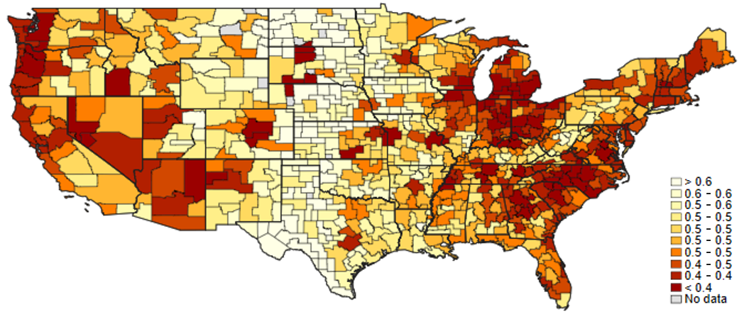

FIGURE II

Gini Coefficient by CZ

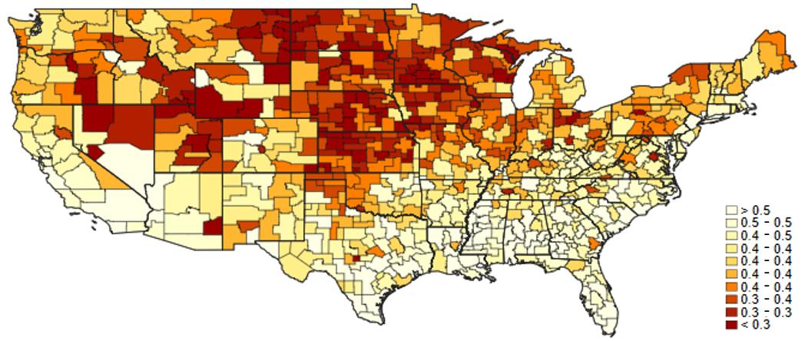

FIGURE III

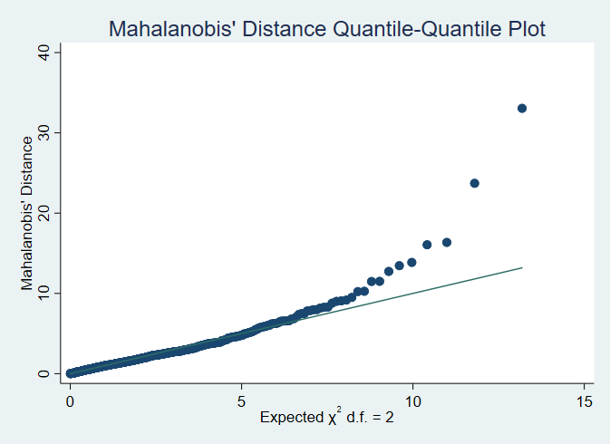

The relationship between P(B) and Gini coefficient across US CZs is summarized in Table III and Figure IV. In the basic linear regression, the estimated coefficient on the Gini coefficient is around -0.27, with a fairly wide 95% confidence interval of (-.44, -.09). A CZ with a Gini coefficient in the 75th percentile is estimated to have a P(B) of just 0.03 lower than at the 25th percentile. Similarly, P(B) is expected to be 0.05 lower in the 90th compared to 10th percentile. Based on the linear specification, P(B) and the Gini coefficient seem to have a statistically significant, yet small relationship. The linear fit can be seen in Figure IV and includes outliers.

In the quadratic and cubic specifications, the outliers, Friday Harbor and Andrews, become relevant. Leaving these two CZs in, the favored model by sequential hypothesis testing is the cubic model. These fitted values are plotted as “Inc. Outliers” in Figure IV. Visually, the downturn in this cubic curve seems driven by the two outliers in purple. Indeed, removing these outliers results in a cubic regression with no coefficients significantly different from 0 at the 5% significance level (column 5 of Table III).

Excluding outliers, the favored model is a quadratic shown by column 4 of Table III and by the “Exc. Outliers” curve on Figure IV. This curve decreases until a Gini coefficient of about 0.497, which is at about the 89th percentile. Thus, the favored specification describes a decreasing relationship between P(B) and Gini coefficient for the majority (89%) of the CZs. For the upper 11% (in terms of Gini coefficient) of the data, the predicted values slope upwards. This is inconsistent with previous findings (Corak 2013, Chetty et al. 2014a). Since this upwards slope takes effect past most of the data and the very tail end appears to be affected by only a few CZs, I focus most of my attention on the downward trending portion of the curve.

TABLE III

|  |  |  |  |  |  |
| --- | --- | --- | --- | --- | --- |
| P(B) and the Gini Coefficient Across CZs within the US | | | | | |
|  | (1) | (2) | (3) | (4) | (5) |
|  | Linear | Quadratic | Cubic | Quadratic Exc. Outliers | Cubic Exc. Outliers |
|  |  |  |  |  |  |
| Gini Coefficient | -0.267** | -1.295** | -3.696** | -1.836*** | -2.819 |
|  | (0.0859) | (0.381) | (1.244) | (0.482) | (1.744) |
|  |  |  |  |  |  |
| Gini Coefficient2 |  | 1.181** | 6.312* | 1.847*** | 4.149 |
|  |  | (0.375) | (2.401) | (0.498) | (3.675) |
|  |  |  |  |  |  |
| Gini Coefficient3 |  |  | -3.469* |  | -1.741 |
|  |  |  | (1.501) |  | (2.533) |
|  |  |  |  |  |  |
| Constant | 0.612*** | 0.827*** | 1.184*** | 0.934*** | 1.069*** |
|  | (0.0354) | (0.0927) | (0.210) | (0.112) | (0.272) |
| Observations | 729 | 729 | 729 | 727 | 727 |
| R-squared | 0.096 | 0.133 | 0.144 | 0.144 | 0.145 |
| Standard errors in parentheses | |  |  |  |  |
| * p<0.05 ** p<0.01 *** p<0.001 | | |  |  |  |

With the favored quadratic specification, a CZ with the Gini coefficient that minimizes the predicted P(B) has a predicted P(B) of 0.02 lower than CZ at the 25th percentile of Gini coefficients and 0.07 lower than one at the 10th percentile. This model predicts moderately greater values of P(B) at the lowest end of the Gini coefficient distribution than at the higher values of the Gini coefficient, with smaller changes in the middle. The coefficient estimates for the quadratic models are substantially impacted by the exclusion of the 2 outliers, whereas the linear model coefficient is not substantially affected.

FIGURE IV

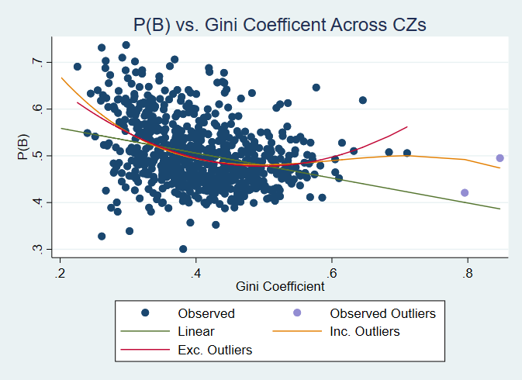

The geographic differences in this relationship give more insight into why the relationship may be quadratic nationwide. The regional decomposition is summarized in Figure V and Table IV. Consistent with the results in Table II and the first two figures, the Midwest (omitted in regression) is unique. The 252 CZs that make up the Midwest exhibit the steepest relationship in this paper, with an estimated slope of -0.93 and 95% confidence interval of (-1.12, -.659). A Midwest CZ with a Gini coefficient in the 75th percentile of Midwest CZs is expected to have an average P(B) about 0.06 lower than at the 25th, and the difference is 0.11 for the 90th and 10th percentiles.

The other three regions exhibit much flatter relationships between P(B) and the Gini coefficient. These three regions have visible outliers at the upper end of the Gini coefficient distribution, although excluding them only substantially effects linear model of the Northeast, which goes from an interaction term coefficient of 0.85 with the single outlier to 0.629 without it. The Northeast only has 42 CZs, so I focus on the other regions which all have more than 150. Excluding outliers, the Midwest and South also have quadratic relationships. These quadratic curves lay close to their respective linear fits for the majority of the data.

FIGURE V

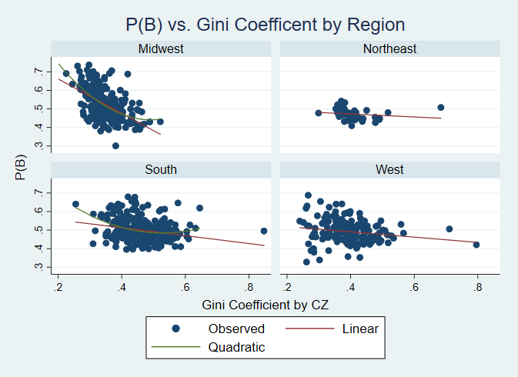

The regional breakdown provides a possible explanation for the favored quadratic fit in the original regressions. The Midwest CZs tend to have a high P(B), low Gini coefficient, and steep relationship between the two. The steep relationship in the Midwest coupled with flatter relationships in the other regions seem to roughly trace out a convex relationship. However, there is a lot of overlap on the regional scatter plots and it is not clear that this is a major factor explaining the quadratic relationship.

TABLE IV

|  |  |  |  |  |  |  |  |  |  |  |  |  |
| --- | --- | --- | --- | --- | --- | --- | --- | --- | --- | --- | --- | --- |
| P(B) vs. Gini Coefficient with Geographic Differences | | | | | | | | | | | | |
|  | (1) | | (2) | | | (3) | | | (4) | | | (5) | | |
|  | Basic | | Regional | | | Urban | | | Nonurban | | | Nonurban Quadratic | | |
| Gini Coefficient | -0.267** | | -0.928*** | | | 0.0277 | | | -0.255* | | | -0.732 | | |
|  | (0.0859) | | (0.134) | | | (0.0744) | | | (0.0951) | | | (0.430) | | |
|  |  | |  | | |  | | |  | | |  | | |
| Gini Coefficient2 |  | |  | | |  | | |  | | | 0.551 | | |
|  |  | |  | | |  | | |  | | | (0.399) | | |
|  |  | |  | | |  | | |  | | |  | | |
| Northeast X |  | | 0.847*** | | |  | | |  | | |  | | |
| Gini Coefficient |  | | (0.169) | | |  | | |  | | |  | | |
|  |  | |  | | |  | | |  | | |  | | |
| South X |  | | 0.716*** | | |  | | |  | | |  | | |
| Gini Coefficient |  | | (0.154) | | |  | | |  | | |  | | |
|  |  | |  | | |  | | |  | | |  | | |
| West X |  | | 0.786*** | | |  | | |  | | |  | | |
| Gini Coefficient |  | | (0.179) | | |  | | |  | | |  | | |
|  |  | |  | | |  | | |  | | |  | | |
| Constant | 0.612*** | | 0.847*** | | | 0.454*** | | | 0.632*** | | | 0.731*** | | |
|  | (0.0354) | | (0.0509) | | | (0.0293) | | | (0.0381) | | | (0.104) | | |
| Regional Fixed Effects | No | Yes | | | No | | | No | | | No | | |
| Observations | 729 | 729 | | | 325 | | | 404 | | | 404 | | |
| R-squared | 0.096 | 0.207 | | | 0.002 | | | 0.078 | | | 0.088 | | |
| Standard errors in parentheses | | | |  | | |  | | |  | | |
| * p<0.05 ** p<0.01 *** p<0.001 | | | | | | |  | | |  | | |

In Table IV, I report linear regressions restricted to urban and nonurban areas separately. The nonurban areas have an estimated slope of -0.26, similar but somewhat shallower than the linear coefficient for the whole country, whereas the urban areas have an estimated slope of just 0.03. It cannot be rejected that P(B) and the Gini coefficient are uncorrelated across urban CZs. The nonurban slope is estimated to be slightly steeper when excluding the two outliers mentioned in the first set of regressions.

The urban breakdown provides a more convincing explanation of the quadratic relationship than the regional breakdown. Nonurban CZs have, on average, higher P(B)s, lower Gini coefficients, and a steeper relationship between them. In addition, column 5 of Table IV shows that no quadratic relationship exists in the nonurban CZs. Going from the urban breakdown to the whole country, we see that the negative nonurban relationship and the small to nonexistent urban relationship accumulate to a convex quadratic relationship.

FIGURE VI

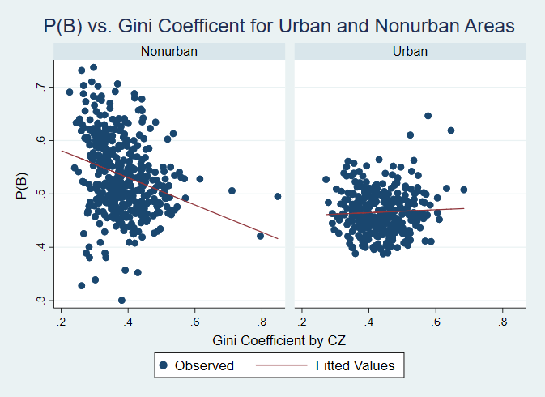

FIGURE VII

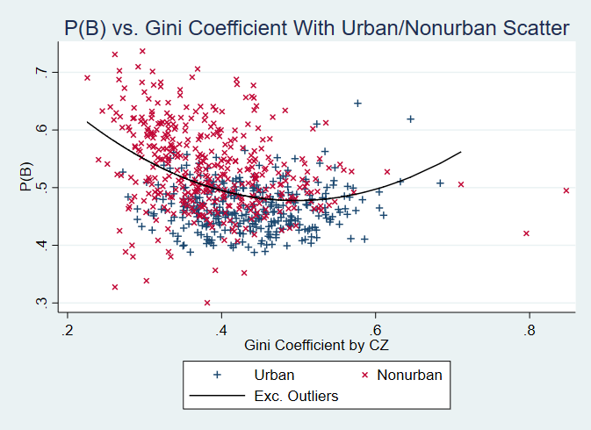

Figure VII best illustrates the possibility that the difference between the urban and nonurban CZs provides some explanation for the quadratic relationship. Figure VII reproduces the favored curve from Figure IV and differentiates between urban and nonurban CZs in the scatter. Here it is visible that the downward trend at lower Gini coefficients is due more to the nonurban CZs, and the flatter trend at higher CZs is due more to urban CZs.

The final set of regressions, summarized in Table V, follow the procedure of Chetty et al. (2014a) Online Appendix Table VIII. Here, the Gini coefficients and P(B) are standardized to have a mean of 0 and variance of 1. The State FEs column reports a coefficient very similar to the baseline, implying that the overall trend is not simply explained by the Midwest, for example, having higher P(B) and lower Gini coefficients than the rest. In other words, the location of the Midwest scatter generally being in the upper left of the plots is likely not the only reason for the negative nationwide relationship. However, I argue in my discussion of Table IV and Figure V that this characteristic in conjunction with the relative trends between the regions may offer some explanation for the quadratic relationship as a whole.

The Population Weighted regression estimates a positive, yet imprecisely estimated slope. This does differ substantially from the Baseline column regression. A possible explanation is seen in the urban and nonurban regressions. The urban CZs, which tend to be more populous, are estimated to have a small or nonexistent relationship between P(B) and the Gini coefficient. The Urban Only column is consistent with my urban only regression in Table IV. The Controls column regression includes variables for the percent of population that is black and the income growth from 2000-2010. Here, the estimated slope is shallower than the Baseline regression and imprecisely estimated, providing evidence that P(B) and Gini coefficients are not causally linked, and serving as a reminder that the purpose of this paper is only to describe the relationship.

TABLE V

|  |  |  |  |  |  |  |  |  |  |
| --- | --- | --- | --- | --- | --- | --- | --- | --- | --- |
| Alternative Specifications of P(B) on Gini Coefficients | | | | | | | | | |
|  | (1) | | (2) | | (3) | (4) | | (5) | | |
|  | Baseline | | State FEs | | Pop. Weighted | Urban Only | | Controls | | |
| Gini Coefficient | -0.309*** | | -0.28*** | | 0.186 | 0.049 | | -0.161 | | |
|  | (0.1) | | (0.063) | | (0.107) | (0.132) | | (0.102) | | |
| Standard errors in parentheses | |  | |  | | |  | |  |
| * p<0.05 ** p<0.01 *** p<0.001 | | | | | | | | | |

**Conclusion**

I find that the probability of being better off than one’s parents if born to parents in the bottom four income quintiles (P(B)) by CZ is related to the Gini coefficient of the CZ by a convex quadratic curve, with almost 90% of the CZs on the decreasing portion of the curve. I decompose this relationship geographically and consider the possibility that geographic differences help explain the quadratic relationship.

The Midwest and urban areas prove to be unique in this analysis. The CZs in the Midwest have, on average, the lowest Gini coefficients, highest P(B), and steepest relationship between the two. Investigating why the slope in the Midwest is so much steeper than any other regression in this paper could prove fruitful in examining the link between P(B) or mobility in generally and inequality. The answer may relate to the stark differences between urban and nonurban areas in the Midwest, with many of the nonurban areas likely being rural rather than suburban.

Urban CZs are unique in that they exhibit a small or nonexistent relationship between P(B) and inequality. Without knowing the link between mobility and inequality, it is difficult to know why urban areas differ. Chetty et al. (2014a) find that absolute upward mobility is less related to the inequality at the top end of the distribution, especially in cities. If an increase in the Gini coefficient from one city to another is driven greatly by the top 1%’s presence, and the top 1%’s presence is uncorrelated with P(B), then we would expect to see a small relationship between P(B) and the Gini coefficient in urban areas. Perhaps regressions on the Gini coefficient of just the bottom 99% would produce different results in urban areas. Further research could include the population density and income segregation of a CZ in the regression specifications to see if the proximity of families in different quintiles and general economic diversity alters the relationship of P(B) with inequality.

The negative coefficient in the simple regression of P(B) on the Gini coefficient is in general agreement with regressions by Chetty et al. (2014a) and Corak (2013). However, the urban only regression in this paper differs from those of Chetty et al. (2014a). They find a negative coefficient when regressing absolute mobility on the Gini coefficient in urban areas, consistent with their baseline estimates. This provides evidence that P(B) is in some way measuring a different phenomenon from alternative measures of mobility. The absolute upward mobility measure Chetty et al. (2014a) use is the expected income percentile of a child with parents in the 25th percentile. This discrepancy may be due to P(B)’s inclusion of children with parents up to the 80th percentile. If the relative unimportance of the top 1% income share in predicting mobility is the main explanation of the small relationship between P(B) and the Gini coefficient in urban areas, then this discrepancy with Chetty et al. (2014)’s results would imply P(B) is even less dependent on top income inequality than absolute upward mobility.

Future research on the probability of being “better off” than one’s parents may want to investigate the relation between P(B) and political opinion. The areas in Table II with the highest P(B) (Midwest, South, Nonurban) also tend to be more conservative. It would be interesting to investigate whether this characteristic of the area drives people to believe more in conservatism and personal responsibility or whether these political opinions and beliefs manifest themselves, if either.

**References**

Acemoglu, D., and D. Autor (2011). “Skills, Tasks and Technologies: Implications for

Employment and Earnings.” in *Handbook of Labor Economic*s, ed. by O. Ashenfelter,

and D. Card, vol. 4b. North Holland.

Chetty, R., N. Hendren, P. Kline, and E. Saez (2014a). “Where is the Land of Opportunity? The

Geography of Intergenerational Mobility in the United States.” *The Quarterly Journal of Economics 129* (4), 1553–1623.

Chetty, R., N. Hendren, P. Kline, E. Saez, and N. Turner (2014b). “Is the United States Still a

Land of Opportunity? Recent Trends in Intergenerational Mobility.” *American Economic Review Papers and Proceedings* (5), 141–147.

Corak, M. (2013). “Income Inequality, Equality of Opportunity, and Intergenerational

Mobility.” *Journal of Economic Perspectives,* 27 (3): 79–102.

Krugman, P. (2013). “Greg Mankiw and the Gatsby Curve.” *The New York Times*

**Appendix**

In Stata, I use each of the following equations to calculate the corresponding value for every CZ where the data is available. For my actual calculations I use the final term of each sequence of equalities.

Below, I add equalities to the first equation shown in the Methodology section for added clarity. The first equality follows by the definition of conditional probability. The numerator in the second equality follows the definition of event as a child being in a higher income quintile than his or her parent and since are disjoint for all . The final equality follows because .

The equalities below follow from the Law of Total Probability since , , , and are disjoint events whose union makes up all of .

The first equality below is how I define P(B). The second equality follows from the definition of conditional probability. The denominator equals and is the sum of the probability of disjoint events for .